Dutch Logic PhD day - Location

Room 5161.0165 in the Bernoulliborg

Address: Nijenborgh 9, 9747 AG Groningen
(At the Zernike Campus)

NB: the entrance of the building is on the east side (not facing the street)

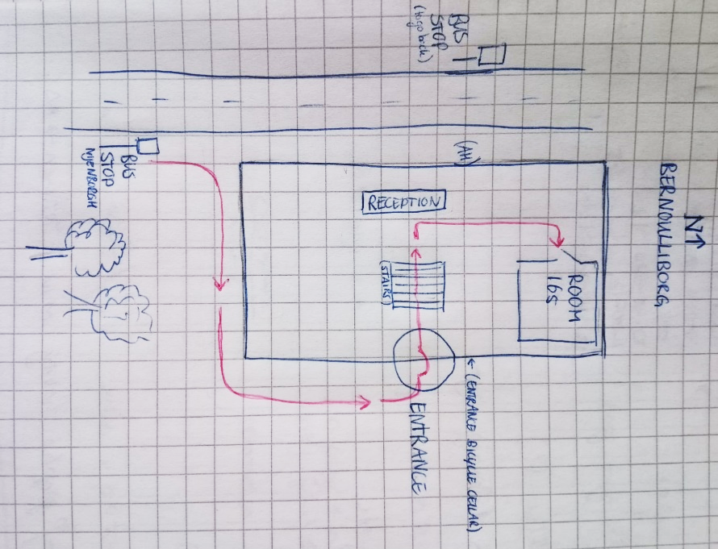
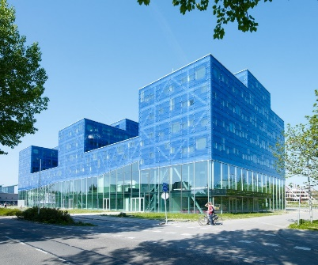

From Groningen Hoofdstation:
By bus (+/- 20 minutes) to bushalte Nijenborgh
Line 15 to Zernike Campus or
Line 1 to P+R Reitdiep
See also https://9292.nl/reisadvies

By OV-fiets (+/- 16 minutes)
See for a cycling route https://www.rug.nl/about-ug/practical-matters/slimme-route?lang=en (or Google Maps…)

